SUNDANCE1 RV RESORT – ACTIVITIES OFFICE
NEWS BLAST – NOVEMBER 4, 2022
It’s Friday again, time for an Activities update, are you ready for it?
I hope you all get a chance to enjoy the Country Store this morning, there’s breakfast and coffee at the “COOP” and a place for “him” to sit while you shop how great is that ladies, if you stay late we’ll serve him lunch too!! I wish we could control the weather; it’ll be cool out there for you and the vendors.
So what’s happening this week.....
TONIGHT-FRIDAY NOV 4^{th:} Christmas Float and Electric Light Parade—Informational meeting tonight NOV 4th 6 pm at the Ranch House please join the team to help decorate the winning City of Casa Grande Float

SATURDAY –”Photography Club” meets 9 – 11 am in the Gambling Room followed by “Photo Shop Class” from 11 – 12 pm. In the Gambling Room
SUNDAY – CHURCH starts at 8:30 in the Hole in the Wall, this is non-denominational service.
Monday the Activity rooms are open again --
- ART Barn – Mondays painting with Tim Jones from 1 – 3:30 pm
Spinning with Jane on WEDNESDAY from 9-12 pm
Thursday paint with Cheri O’Brien
Friday – Mandala Dot w/Pam, must sign –up in Activities
  - CACTUS NEEDLES on Monday in the Hole in the Wall at 10 AM
  - CERAMICS is open 9-2 pm on M-W-F and Wednesday evenings after 6 o’clock.
  - CRAFTY LADIES meet in the Hang out Room on Mondays and Fridays from 1-3 pm
  - COMPUTER ROOM – is Open from 9- noon
  - HARDANGER meets on TUESDAY f from 1-3 in the Hang out Room
  - LAPIDARY – is currently closed until further notice
  - SEWING AND QUILTING ROOM is open M-W-TH-F from 8:45 to 3:45 and Tue from 9:15 – 3:45.
  - WOOD CARVERS meet in the Gambling room on Tuesday and Fridays from 9 – noon.
  - JAMMERS PRACTICE in the Hang Out room from 9 – to 11 am Today

Check the Hang out Room and Gambling Room for schedules of numerous cards and games. Schedules also available in Activities.

BUNCO --- ROOM & TIME CHANGE last time, we hear you and found a new time and space for you. HANG OUT ROOM on Monday evenings at 6 pm.
BINGO STARTS TUESDAY NIGHT--- CARD SALES FROM 6 – 6:45 PM—GAME STARTS AT 7.
Grab Your partner and join COUPLES DANCE LESSONS in the Hole in the Wall on Tuesdays from 10 – 12 pm or take classes in LINE DANCING on Tues and Thu at 1:30.
Start your day with Exercise and fitness at the pools with Aquasize, Water Aerobics, Water Exercise, Water Walking and Lap swim. If you don’t like the water head inside the Hole in the Wall for Walk Exercise -- Senior Stretch starts Nov 4th.

OK so your not interested in crafting and don’t want to dance, or ply games then take a trip over to the SPORTS Complex and check out:
Shuffleboard from 9-11
Pickleball, Bocce Ball, RC RaceTrack (1pm T-W & TH) and Water VolleyBall at Pool2 from 1-3 M- W-F.
Spend some quite time in the library or complete a puzzle at Ranch House, or grab a few friends for your own game time or play a game of Cornhole or Bocce Ball.

What did you miss this last week?

Yesterday, the Singles Solo Group luncheon had over 30 participants meet in the Hang Out Room, head their way the first Thursday of the month in the Hang Out Room from 1-2 to see what exciting things they have planned.
Wednesday evening residents enjoyed an evening at the pool with Entertainment and Karaoke by George, enjoying a plate of Nachos from the kitchen “COOP.” On Halloween last Monday evening they enjoyed music at the pool with Bob Villa. Watch the schedule and check out Activities for more planned events in the future.
SPEAKING OF THE FUTURE GET YOUR TICKETS IN ACTIVITIES NOW FOR:
  - Dancing to the music of CLASSIC EXAMPLE – NOV 12th 6 – 9:30 pm
  - A full traditional THANKSGIVING DINNER on Nov 24th. (Interested in helping decorate and coordinate game time after dinner? Join us for an informational meeting in the Hangout Room 1-2 pm on Nov 9th.)
  - HALE THEATER SISTER ACT Tickets on sale for Nov 11th, and Nov 25
  - SIGN UP FOR A LUNCH MEETING with SKY MED from 12-2 on Nov 16th.
  - Purchase tickets for a beautiful Raffle to benefit the Veterans Club donated by the Woodcarvers $1 /ea or 6 for $5.00 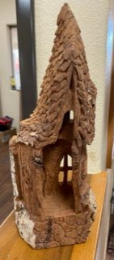
  - Town Council meeting this Wed, put your suggestions, comments, and encouragement in the drop box in Activities.

Whatever you choose to do, have a and enjoy your week at SUNDANCE.

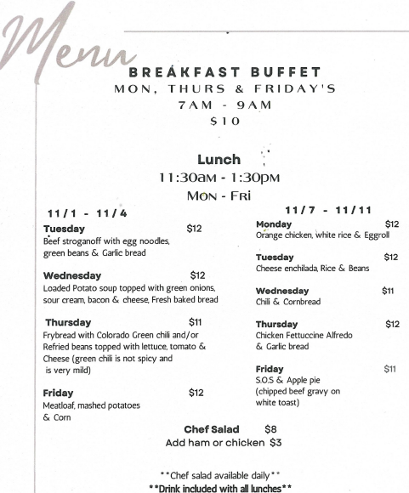

Did you find any mistakes in times and dates? Please let me know,

